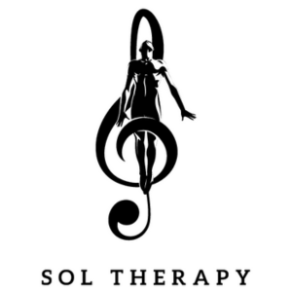
Between the Frequencies: A Night of Meditation, Sound, and Presence at the Suzanne Dellal Centre, presented by Sol Therapy.
In the midst of one of the most challenging periods in our history, we have chosen, as part of White Night, to unite the power of movement, music, and meditation to mend, heal, and uplift. The beautiful spaces of the Suzanne Dellal Centre will be enveloped in an intimate atmosphere, mattresses will be spread across the floors of the halls and studios, and in the heart of the unique ambiance of the Centre-the home of Israeli dance and creation-Israel's leading sound artists and musical creators will devote themselves to a contemporary interpretation of meditative music. A rare opportunity will open up to you: to be exposed to the hidden currents that drive the creative act, to discover the spectrum of musical influences and the hidden sides of their work, and to dive into the essence of a deep meditation.
Throughout the Centre, semi-guided sound meditations based on Zen Buddhist principles will be held, led by artists at the forefront of Israel's electronic and musical scene: Astral Projection, Assaf Amdursky, Omri Smadar, Red Axes, Atar Mayner, Anna Haleta, Ran Slavin, Yotam Avni, and Yehezkel Raz.
Alongside the sound sessions, there will be one-of-a-kind performances specially adapted for this night: The Israel Chamber Orchestra and Hila Ruach will present a concert tribute to the cinematic soundscapes of David Lynch, and Jonathan Daskal will host Shlomi Shaban for a meditative sound journey-a virtuosic and mind-expanding encounter of pianos and keyboards. The program will also include screenings of documentary films on consciousness and sound, and, symbolically and fittingly in the event's new home, meditative dance performances.
The "Sol Therapy" series is based on a deep belief in the healing power of sound-a practice that has accompanied human culture since the dawn of history. Within this framework, sound artists, DJs, and electronic creators who have dedicated their lives to the deep exploration of frequency and sound are invited to lead intimate, reclining sound meditation sessions. These are transformative journeys into consciousness, often with a spiritual character, conducted through music that transcends the boundaries of language and culture, allowing a direct connection to the body and soul.

About Us
For nearly two decades, Yaron Amor and Guy Dreifuss have been active in Israel's cultural and electronic music scene as producers and content creators. Over the years, we have produced some of the largest electronic music events in the country-including large-scale festivals in Hayarkon Park with audiences exceeding 25,000 people, alongside intimate and unique productions at various sites across the country (Masada, Shuni, Ramat Gan Park, Ronit Farm, and more).
Among others, we have hosted hundreds of top-tier international artists alongside the best local creators. In parallel with our production activities, we mentor and manage Israel's leading electronic artists, which provides us with direct access to artists, loyal music communities, and an extensive client base built over 20 years of activity.

